# Celery task fail to write to Elasticsearch

# Issue

Celery task failed with these kinds of traceback (ES client read timeout):

Traceback (most recent call last):

File "/usr/local/lib/python3.8/site-packages/celery/app/trace.py", line 412, in trace_task

R = retval = fun(*args, **kwargs)

File "/usr/local/lib/python3.8/site-packages/celery/app/trace.py", line 704, in __protected_call__

return self.run(*args, **kwargs)

File "/usr/src/app/data-quality/task/lib.py", line 336, in wrapper

raise e

File "/usr/src/app/data-quality/task/lib.py", line 328, in wrapper

do_func = func(*args, **kwargs)

File "/usr/src/app/data-quality/task/metrics/tasks.py", line 294, in data_collection

raise e

File "/usr/src/app/data-quality/task/metrics/tasks.py", line 260, in data_collection

merge_result, rule_exceptions = collect_metrics_with_rule_params(

File "/usr/src/app/data-quality/core/utils/collection.py", line 270, in collect_metrics_with_rule_params

res = run_database(period, cur_begin_dt, cur_end_dt, metric_rule, load_common_conf)

File "/usr/src/app/data-quality/core/utils/collection.py", line 27, in run_database

return class_obj(common_conf, rule, period, begin_dt, end_dt).run()

File "/usr/src/app/data-quality/core/database/ch_sql.py", line 113, in run

self.dump_results_to_es(index_name, data)

File "/usr/src/app/data-quality/core/database/base.py", line 78, in dump_results_to_es

es_clt.bulk_put(one, index_name)

File "/usr/src/app/data-quality/core/connector/elasticsearch_req.py", line 133, in bulk_put

self.bulk_flush()

File "/usr/src/app/data-quality/core/connector/elasticsearch_req.py", line 137, in bulk_flush

self.es_clt_write.bulk(self.bulk_lst)

File "/usr/local/lib/python3.8/site-packages/elasticsearch/client/utils.py", line 152, in _wrapped

return func(*args, params=params, headers=headers, **kwargs)

File "/usr/local/lib/python3.8/site-packages/elasticsearch/client/__init__.py", line 455, in bulk

return self.transport.perform_request(

File "/usr/local/lib/python3.8/site-packages/elasticsearch/transport.py", line 392, in perform_request

raise e

File "/usr/local/lib/python3.8/site-packages/elasticsearch/transport.py", line 358, in perform_request

status, headers_response, data = connection.perform_request(

File "/usr/local/lib/python3.8/site-packages/elasticsearch/connection/http_requests.py", line 176, in perform_request

raise ConnectionTimeout("TIMEOUT", str(e), e)

elasticsearch.exceptions.ConnectionTimeout: ConnectionTimeout caused by - ReadTimeout(HTTPSConnectionPool(host='esadsquality.vip.ebay.com', port=443): Read timed out. (read timeout=10))

# SOP

1. Check ES disk usage and CPU usage in <https://console.sherlock.io/d/vEO-N6qmz/production-monitoring?orgId=1&var-escluster=esadsquality-slc&var-name=All&from=now-3h&to=now>
2. If CPU usage is high for some ES instances (e.g. near 100%), check tasks using GET _tasks in dev console of Kibana: <https://esadsquality-kibanaslc.vip.ebay.com/app/dev_tools#/console>
3. Find out the tasks which causing CPU usage high (usually there will be a lot of similar tasks). For example, if someone triggered some delete_by_query operations, we can get all related tasks using GET _tasks?detailed=true&actions=*/delete/byquery in dev console
4. Dump the tasks results to local json file, for example: tasks.json
5. Use the Python script to generate commands to cancel these delete_by_query operations (don't forget to change the file path and conditions in the code):
6. import json
7. with open('/Users/chonyu/Downloads/tasks.json') as f:
8. tasks = json.load(f)
9. for node in tasks['nodes']:
10. task_list = tasks['nodes'][node]['tasks']
11. for task_id in task_list:
12. # You should replace the condition for your task
13. if 'delete-by-query [collect_rule_ch_sre_sales_hourly_business_none_replace]' == task_list[task_id]['description']:

print(f'POST _tasks/{task_id}/_cancel')

1. Execute the commands in dev console (you can select multiple lines to execute them together), like:

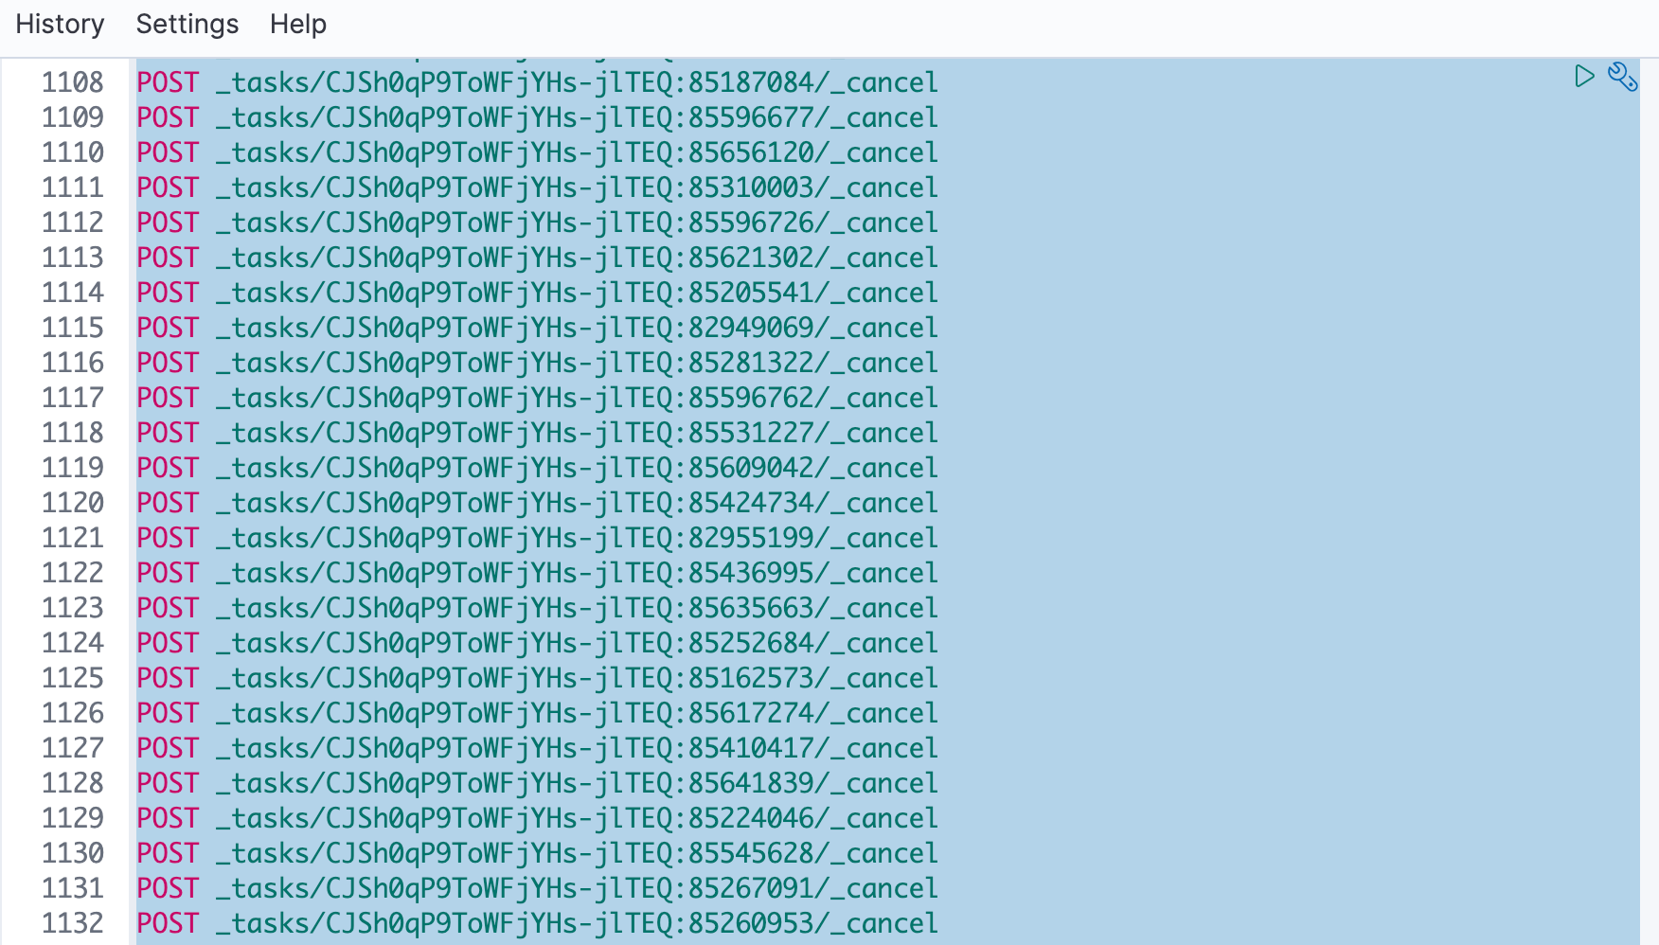

1. Check again the CPU usage, the usage should decrease in a few minutes. And rerun the failed tasks, they should success.